## Modeling of motor

# Define parameters for motor sampling

**Test with L298N motor driver**

We examine the linear relation between the input $(\%PWM)$ and the output revolution of the motor’s shaft $(rpm)$. To do that, we $PWM$ signal is fed into the motor, duty cycle from $5-100\%$. After that, we read the $rpm$ signal from the encoder.

Table 4.1. Table of rpm data of motor

|  |  |
| --- | --- |
| **%PMW** | **rpm** |
| 5% | 0 |
| 10% | 0 |
| 15% | 28.133 |
| 20% | 50.7385 |
| 25% | 69.346 |
| 30% | 85.8935 |
| 35% | 104.143 |
| 40% | 118.375 |
| 45% | 129.678 |
| 50% | 141.245 |
| 55% | 151.046 |
| 60% | 161.361 |
| 65% | 168.31 |
| 70% | 176.172 |
| 75% | 181.71 |
| 80% | 187.617 |
| 85% | 192.982 |
| 90% | 198.063 |
| 95% | 202.461 |
| 100% | 219.046 |

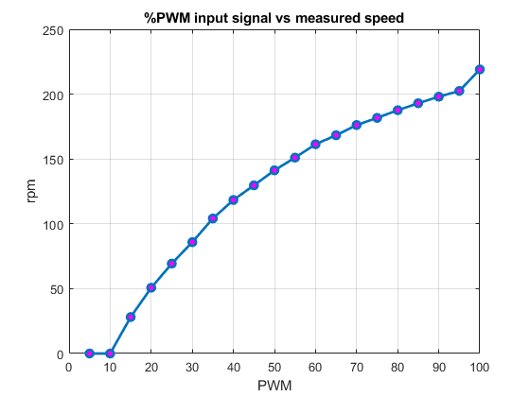

Fig 4.2. %PWM vs measured velocity (rpm) graph

**Test with TB6612 motor driver**

Follow the same procedure as above:

Table 4.2. Table of rpm data of motor

|  |  |
| --- | --- |
| **%PMW** | **rpm** |
| 5% | 0 |
| 10% | 21.4281 |
| 15% | 33.0784 |
| 20% | 45.6978 |
| 25% | 59.2714 |
| 30% | 71.612 |
| 35% | 85.1655 |
| 40% | 98.9197 |
| 45% | 111.3331 |
| 50% | 123.494 |
| 55% | 136.1053 |
| 60% | 149.1838 |
| 65% | 162.2477 |
| 70% | 176.4101 |
| 75% | 187.6647 |
| 80% | 198.401 |
| 85% | 214.4792 |
| 90% | 229.4622 |
| 95% | 241.7738 |
| 100% | 254.8411 |

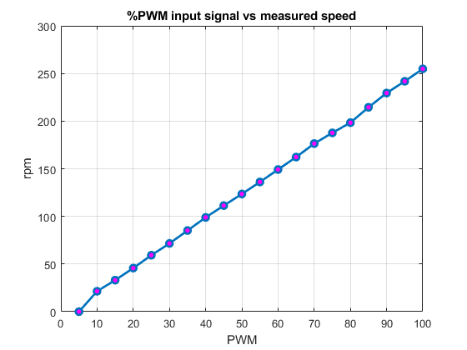

Fig 4.3. %PWM vs measured velocity (rpm) graph

We see that the TB6612 helps making the relationship between PWM and speed linear better than L298N.

# Determine motor transfer function

Prepare data for SIT

Let a PWM input changes in the function $f\left(t\right)=127.5\sin{(t)}+127.5$

$$→T=6.28(s)$$

Then:

$$N×δt=m×T$$

$δt$ is from the Nyquist criterion

$$f_{Sampling}≥2f_{signal}→δt≤\frac{1}{2}T$$

Our $T$ satisfy the condition.

$$→N×0.022=m×6.2832$$

We choose $N=1428; m=5$ (must be integer)

For the motor, the output signal is the revolution of the output shaft $(rpm)$, input is $PWM$ in a sinusoidal wave. So in order to obtain the motor transfer function, we will provide the motor with $\%PWM$, then measure the revolution of the output shaft.

* Plotting the input and output data. We obtain the following graph:

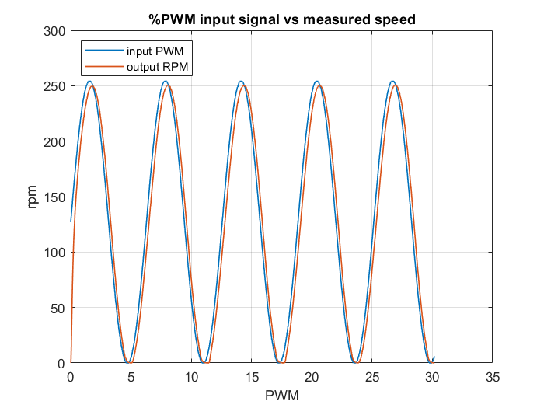

Fig 4.3. Measured speed of the motor

* Using MATLAB System Identification Toolbox (SIT), we yield the following transfer function of the motor-driver plant 1

$$G\left(s\right)=\frac{1.008}{0.18162×s+1}= \frac{5.55}{s+5.51}$$

|  |  |
| --- | --- |
|  | Current value |
| Settling time | $$T_{s}=0.18162×4=0.72648 (s)$$ |
| Overshoot | $$1\%$$ |
| Steady-state error for step input | $$0.01$$ |

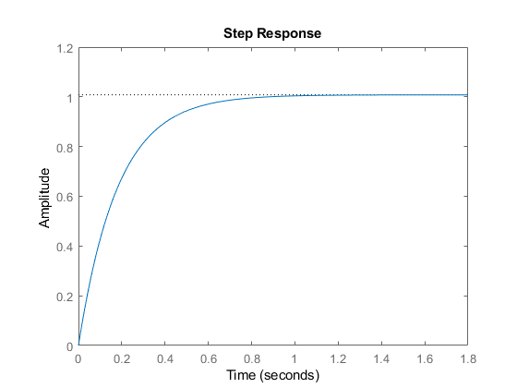

Fig 4.4. Step response graph of the transfer function

We want to make the motor-driver settling time smaller than the sampling time of the microcontroller so that it can work fine. $T_{s}<δt$

Select $T_{s}=0.015 s$

Keep the overshoot at this moment. We also want to remove steady-state error for step input

With the above requirements, we implement the PI controller for this motor-driver plant. Assuming negative unity feedback, the forward transfer function will be

$$K\frac{\left(s+a_{2}\right)}{s}×\frac{5.55}{s+5.51}$$

$$ζ=-\frac{\ln\left(\%OS\right)}{\sqrt{{\ln\left(\%OS\right)}^{2}+π^{2}}}=-\frac{\ln\left(0.01\right)}{\sqrt{{\ln\left(0.01\right)}^{2}+π^{2}}}=0.8261$$

$$T_{s}=0.015=\frac{-\ln\left(0.02\sqrt{1-ζ^{2}}\right)}{ζω_{n}}→ω_{n}=\frac{-\ln\left(0.02\sqrt{1-{0.8261}^{2}}\right)}{0.015×0.8261}=361.991$$

Then the PI controller:

$$\frac{K\left(s+a_{2}\right)}{s}$$

Desired characteristics equation for negative unity feedback:

$$1+\frac{K\left(s+a_{2}\right)}{s}\frac{5.55}{s+5.51}=0→s^{2}+5.51s+5.55Ks+5.55Ka_{2}=0→\left\{\begin{aligned}ω_{n}=\sqrt{5.55Ka_{2}}=361.991 \\ ζ=\frac{5.51+5.55K}{2ω_{n}}=\frac{5.51+5.55K}{2×361.991}=0.8261\end{aligned}→\left\{\begin{aligned}a_{2}=\frac{{361.991}^{2}}{106.7696×5.55}=221.1336 \\ K=106.7696\end{aligned}\right.\right.$$

The open loop TF:

$$\frac{106.7696\left(s+221.1336\right)}{s}×\frac{5.55}{s_{0}+5.51}$$